ACTIVITY 4

NFL OVERTIMES

# DIRECTIONS

Have one group member upload this docx file to your Google Drive and share it with your groupmates and your instructor. Name your document “**GroupX_Activity4”** (where X is your group number). Work together to type up your responses to each question. Download your document as a PDF and submit this to Canvas individually.

# INTRODUCTION

The National Football League (NFL) uses an overtime period to determine a winner for games that are tied at the end of regulation time. Between 1974 and 2009, the overtime period started with a coin flip that determined which team got the ball first in overtime, and then the team that scored first won the game. Rules were changed after 2009 because fans and players both believed that these rules were unfair for the team that lost the coin flip. That is, they believed that the team that won the coin flip and got the ball first in overtime had an advantage at winning the game. Between 1974 and 2009, there were 428 games that went to overtime and 240 of them were won by the team that won the coin toss. In this activity, we will investigate the following research question:

**

# EXAMINING THE SAMPLE DATA

1. Based on the data given above, what percentage of the teams that won the coin toss ended up winning the game?
2. If we assume that the overtime rules were actually “fair” and gave neither team an advantage, what percentage of the teams that won the coin toss would you expect to win the game?
3. Based on your responses to questions 1 and 2, are you convinced that the teams that won the coin flip had an advantage at winning the games? Or is it possible that the teams that won the coin flip really had no advantage at winning the games, and the observed percentage (from question 1) is the result of random chance? Explain your thinking.

# MODELING NFL OVERTIMES IN TINKERPLOTS

1. Discuss in your group how you might simulate this NFL overtime scenario if you were to assume that teams that win the coin flip have no advantage for winning the football game. Set-up a TinkerPlots sampler model that reflects your discussion. As part of your work, be sure to:
   1. Copy and paste a picture of your TinkerPlots sampler below.
   2. Describe why you set the model up the way you did. In particular, please discuss how the model you constructed incorporates the assumption of “the team that won the coin flip had no advantage at winning the game.”
   3. State what the repeat and draw values are set to and explain why they are set to those values.
   4. Describe what elements you used to populate the device(s) in your sampler and why.
   5. Describe if the device(s) in your sampler are set to sample with or without replacement and explain why.
   6. Describe what will happen when you click run and how this relates to the problem context. (Hint: If you are struggling, run the model with a slow speed)
2. Run a single trial of the simulation and make a plot of the results that allows you to see the number of times that each outcome occurred.
   1. Copy and paste this plot below.
   2. Describe what a dot in this plot represents.
   3. What information are you collecting from this plot?
3. Based on the plot from question 5, how many times did the coin-flip winning team end up winning the game?
4. Run at least 250 trials of the simulation and have TinkerPlots collect on the *number of wins for the coin-flip winning team*. (Remember: use the “collect statistics” feature of TinkerPlots to help you do this.) Plot the results from your trials and paste this plotbelow. What does a dot in this plot represent?
5. In the full class discussion, you saw other groups’ TinkerPlots samplers that modeled this scenario. Think about one approach that differed from the one you used above and answer the following questions:
   1. How did this sampler differ from the one you created?
   2. How did this sampler generate and organize data?
   3. What strategies did this group use to organize and interpret the data? How did the labels for each attribute impact this analysis?

# EVALUATING EVIDENCE WITH PROBABILITIES

1. In your distribution, what is the probability that 240 or more of the 428 games will result in the coin-flip-winning team winning the game? (It may help to review the tutorial below to find this probability)

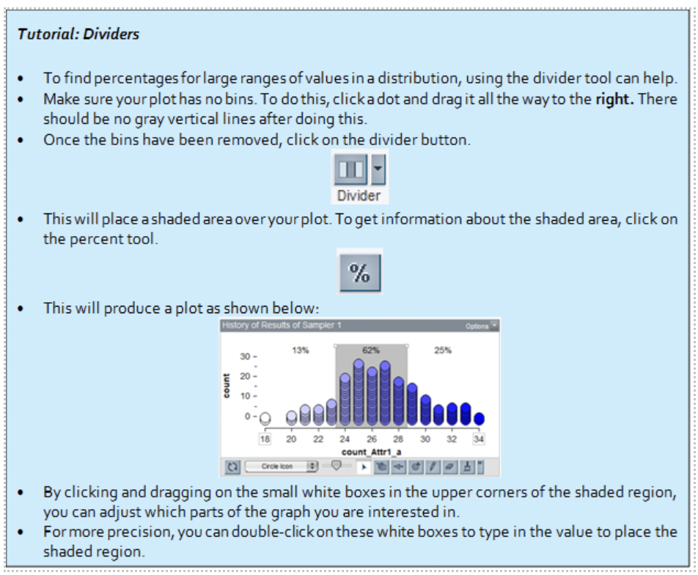

1. Write an interpretation of this probability in the context of the problem. Think about the assumptions that went into creating your sampler model!
2. What does this probability indicate about the research question? It may help to write out in words what your probability from problem 9 means in light of these assumptions.
3. If you had found a higher probability in Problem 9, would this indicate more or less evidence that the old NFL overtime rules gave the coin flip winning team an advantage at winning the game? Explain why.